Question 1
BEGIN

EXECUTE IMMEDIATE '
CREATE TABLE Customer (
Customer_ID VARCHAR2(10) PRIMARY KEY,
First_Name VARCHAR2(50) NOT NULL,
Surname VARCHAR2(50),
Address VARCHAR2(100),
Contact_Number VARCHAR2(20),
Email VARCHAR2(100)
)';

EXECUTE IMMEDIATE '
CREATE TABLE Employee (
Employee_ID VARCHAR2(10) PRIMARY KEY,
First_Name VARCHAR2(50) NOT NULL,
Surname VARCHAR2(50),
Contact_Number VARCHAR2(20),
Address VARCHAR2(100),
Email VARCHAR2(100)
)';

EXECUTE IMMEDIATE '
CREATE TABLE Donator (
Donator_ID VARCHAR2(10) PRIMARY KEY,
First_Name VARCHAR2(50) NOT NULL,
Surname VARCHAR2(50),
Contact_Number VARCHAR2(20),
Email VARCHAR2(100)
)';

EXECUTE IMMEDIATE '
CREATE TABLE Donation (
Donation_ID VARCHAR2(10) PRIMARY KEY,
Donator_ID VARCHAR2(10) NOT NULL,
Donation VARCHAR2(100),
Price NUMBER(8,2),
Donation_Date DATE,
CONSTRAINT fk_donator FOREIGN KEY (Donator_ID)
REFERENCES Donator (Donator_ID)
)';

EXECUTE IMMEDIATE '
CREATE TABLE Delivery (
Delivery_ID VARCHAR2(10) PRIMARY KEY,
Delivery_Notes VARCHAR2(200),
Dispatch_Date DATE,
Delivery_Date DATE
)';

EXECUTE IMMEDIATE '
CREATE TABLE Invoice (
Invoice_Num VARCHAR2(10) PRIMARY KEY,
Customer_ID VARCHAR2(10) NOT NULL,
Invoice_Date DATE,
Employee_ID VARCHAR2(10),
Donation_ID VARCHAR2(10),
Delivery_ID VARCHAR2(10),
CONSTRAINT fk_customer FOREIGN KEY (Customer_ID)
REFERENCES Customer (Customer_ID),
CONSTRAINT fk_employee FOREIGN KEY (Employee_ID)
REFERENCES Employee (Employee_ID),
CONSTRAINT fk_donation FOREIGN KEY (Donation_ID)
REFERENCES Donation (Donation_ID),
CONSTRAINT fk_delivery FOREIGN KEY (Delivery_ID)
REFERENCES Delivery (Delivery_ID)
)';

EXECUTE IMMEDIATE '
CREATE TABLE Returns (
Return_ID VARCHAR2(10) PRIMARY KEY,
Return_Date DATE,
Reason VARCHAR2(200),
Customer_ID VARCHAR2(10),
Donation_ID VARCHAR2(10),
Employee_ID VARCHAR2(10),
CONSTRAINT fk_return_customer FOREIGN KEY (Customer_ID)
REFERENCES Customer (Customer_ID),
CONSTRAINT fk_return_donation FOREIGN KEY (Donation_ID)
REFERENCES Donation (Donation_ID),
CONSTRAINT fk_return_employee FOREIGN KEY (Employee_ID)
REFERENCES Employee (Employee_ID)
)';

END;
/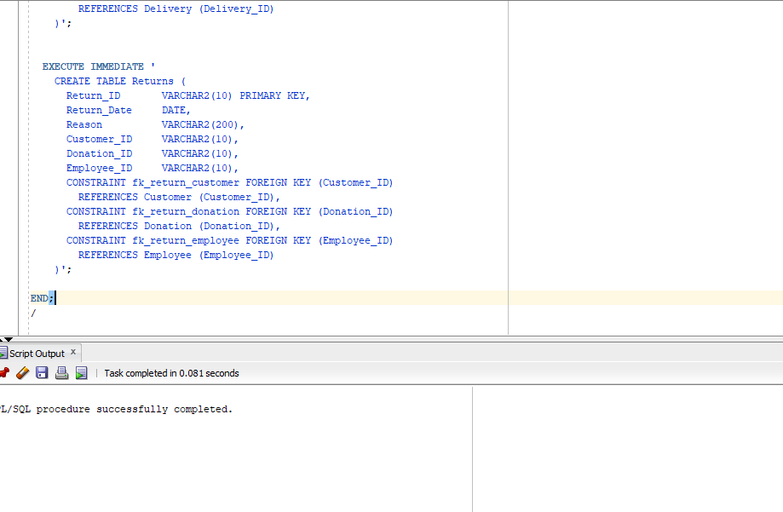
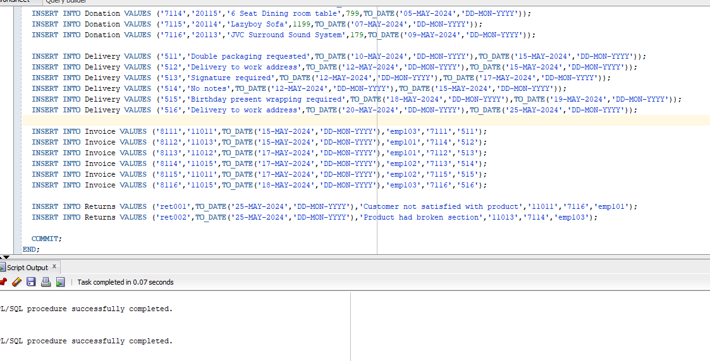

Question 2
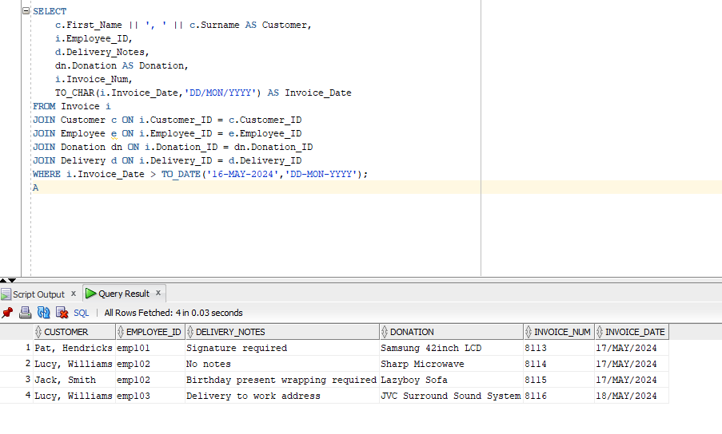
Figure 1– SQL JOIN (W3Schools, 2025)I used the JOIN keyword to combine records of multiple tables so that info from customer, employee, and delivery details appear together in one report.

Question 3

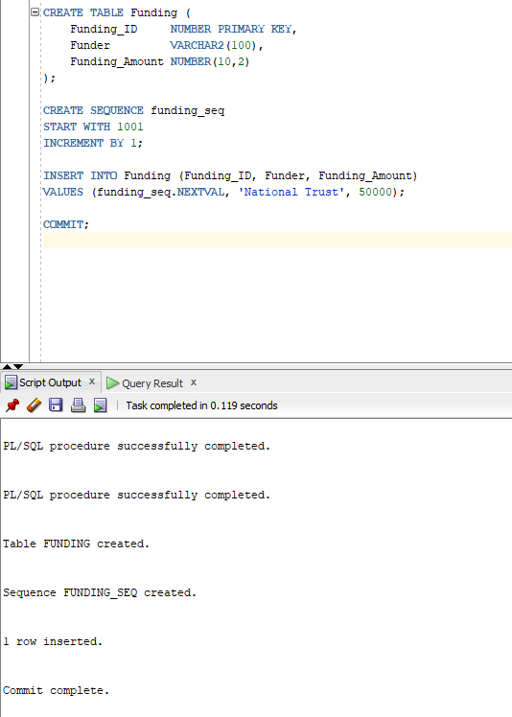
Figure 2– SQL | SEQUENCES(geeksforgeeks, 2025) I used a sequence to automatically create unique IDs for the new funding table.

The sequence automatically generates unique FundingIDs for every new record.
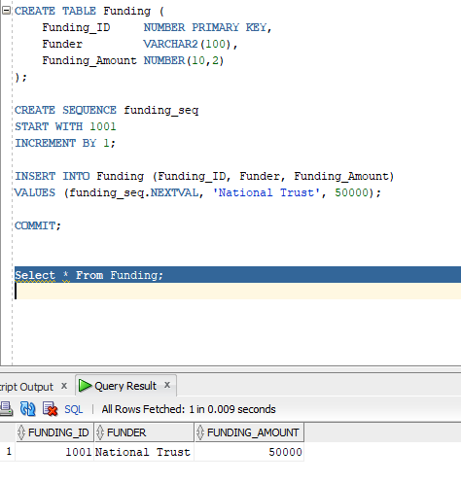

Question 4
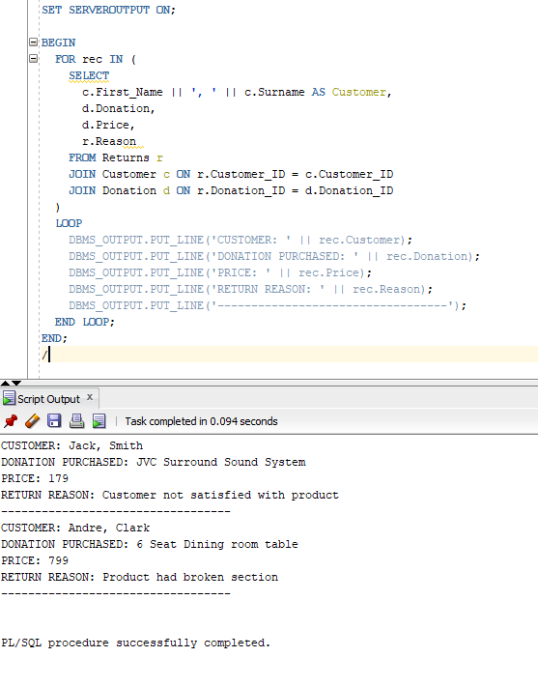
Figure 3-PL/SQL Cursor FOR LOOP(Oracle Tutorial, 2025). I used rec to store each row from the query so I could easily access and display its column values.

Question 5
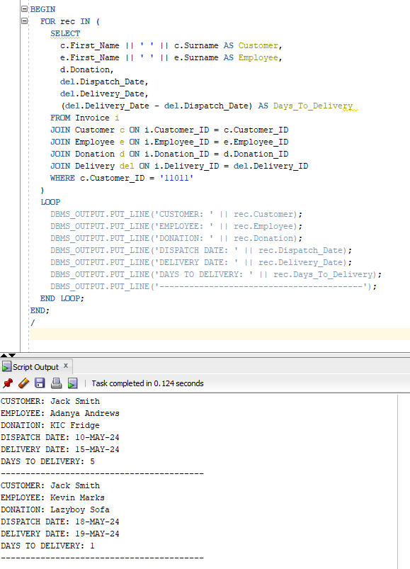

Question 6
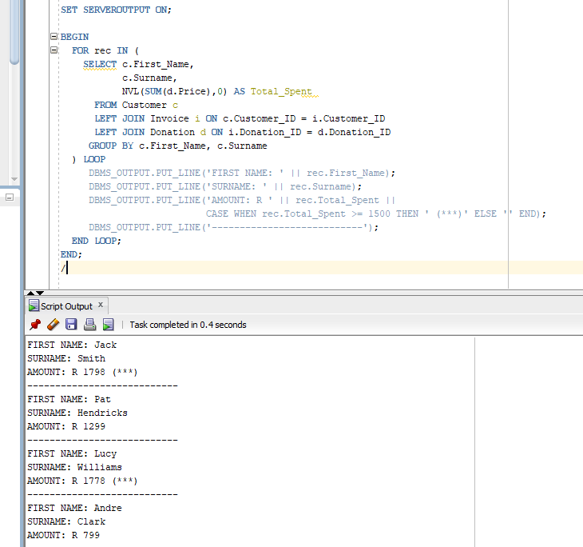
Figure 4-PL/SQL Left Join(geeksforgeeks,2025). I used a LEFT JOIN to display each customers name and total amount spent.
Question 7.1
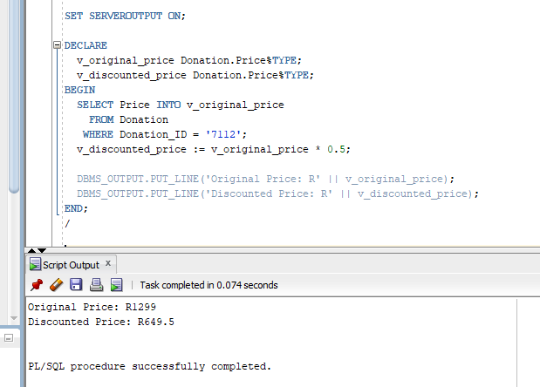
Figure 5-PL/SQL – Cursors %TYPE(tutorialspoint,2025).I used the %TYPE to match the Price column to calculate the discount

Question 7.2
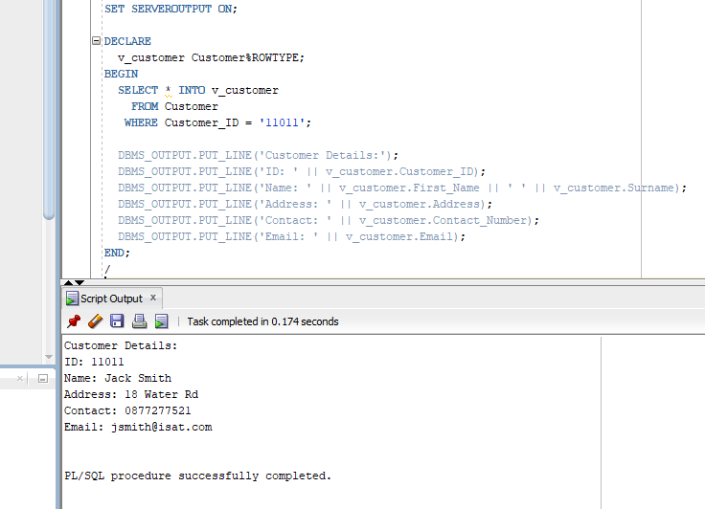
Figure 6-PL/SQL %ROWTYPE Attribute(tutorialspoint,2025).I used %ROWTYPE so that my variable can hold an entire row from the Customer table, making it easy to access all customer info

Question 7.3
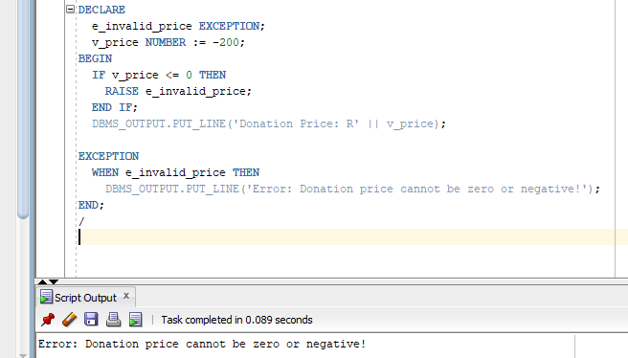
Figure 7-Exception Handling in PL/SQL(geeksforgeeks,2025).I used an exception to show an error when the donation price is zero or negative

Question 8
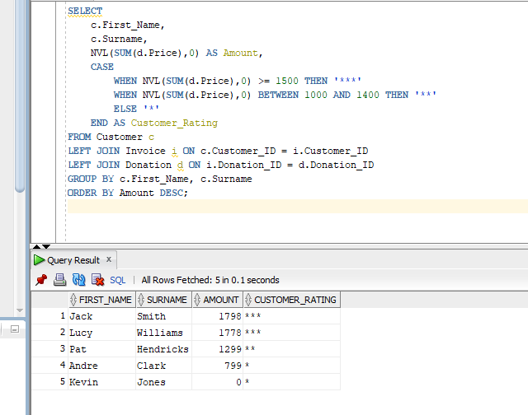
Figure 8-SQL CASE Statement(geeksforgeeks,2025).I used a CASE statement to assign a rating to each customer based on their total spending.

References
geeksforgeeks. 2024. SQL CASE Statement.[online]Available at:< https://www.geeksforgeeks.org/sql/sql-case-statement/> [Accessed 13 October 2025].
geeksforgeeks. 2025. Exception Handling in PL/SQL. [online]Available at:< https://www.geeksforgeeks.org/plsql/exception-handling-plsql/> [Accessed 13 October 2025].
geeksforgeeks. 2025. PL/SQL Left Join. [online]Available at:<https://www.geeksforgeeks.org/plsql/pl-sql-left-join/> [Accessed 13 October 2025].
geeksforgeeks. 2025. SQL | SEQUENCES. [online]Available at:< https://www.geeksforgeeks.org/sql/sql-sequences/> [Accessed 13 October 2025].
OracleTutorial. 2025. PL/SQL Cursor FOR LOOP. [online]Available at:< https://www.oracletutorial.com/plsql-tutorial/plsql-cursor-for-loop/?utm_source=chatgpt.com> [Accessed 13 October 2025].
tutorialspoint.2025. PL/SQL - Cursors. [online]Available at:<https://www.tutorialspoint.com/plsql/plsql_cursors.htm> [Accessed 13 October 2025].
w3schools.n.d. SQL Joins. [online]Available at:< https://www.w3schools.com/sql/sql_join.asp> [Accessed 13 October 2025].

